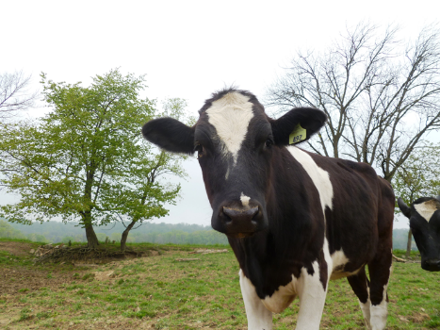

Date & Time

Free

manure

management

plan

workshop

*Financial support for this project is provided by the Pennsylvania Department of   
Environmental Protection through the Chesapeake Bay Implementation Grant and the Clean Water Fund.*

# All farms generating or applying manure MUST have a Manure Management Plan. We can help!

Location: *Location name and address*

Registration is free, but required. Please call ###-###-#### or email __@__.com by DATE.

Please register by DATE to secure your seat!

*Photo by Holly Hunt.*

District Name

Type address here or use Mail Merge to automatically address this publication to multiple recipients.

Address

Your Address Line 2

Your Address Line 3

Your Address Line 4

Please

place

stamp

here