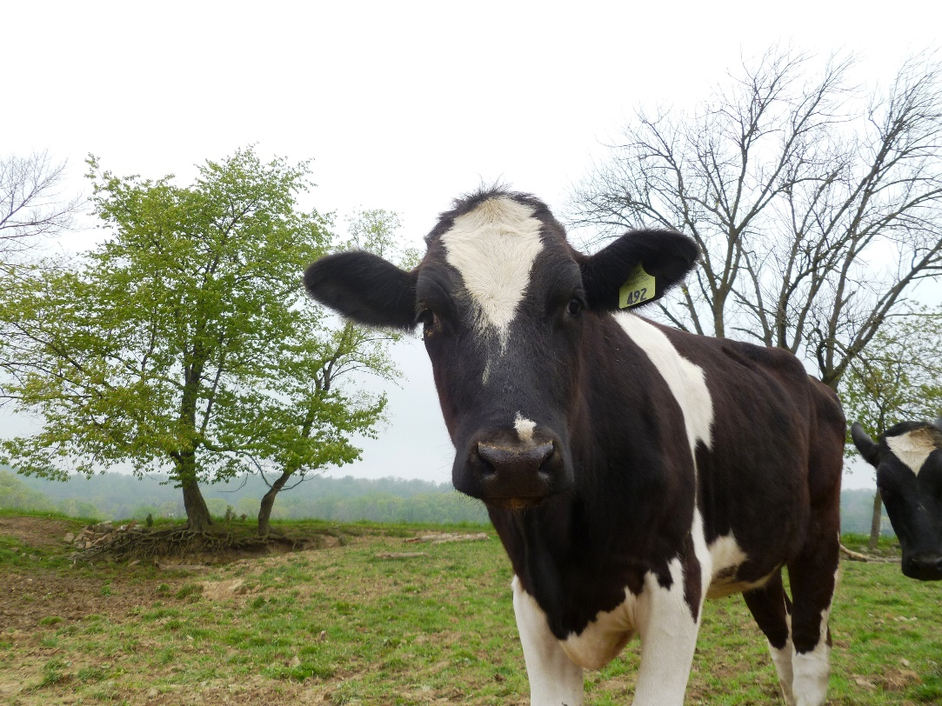  Photo by Holly Hunt.  Date & Time  Free manure management plan workshop  All farms generating or applying manure MUST have a Manure Management Plan. We can help!  Attend this workshop to received guided assistance in writing your manure management plan.  Please register by DATE to secure your seat!  Financial support for this project is provided by the Pennsylvania Department of Environmental Protection through the Chesapeake Bay Implementation Grant and the Clean Water Fund. | Event Location  ────  Directions  ────  Information they should bring with them  ────  Add More Great Info Here!  Registration for this event is free but required.  Please contact:  District Name  Street Address  City, ST ZIP Code  Telephone  E-mail Address  Web Address

