Sample Facebook Post

Sample Photos
Make sure they can clearly see the new hire’s face, with a pleasant facial expression. A natural background is appropriate, but the photo subject should clearly be the individual.

Start Your Post By Clicking the Photo Icon First
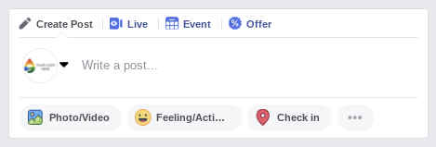Add Photos and Text
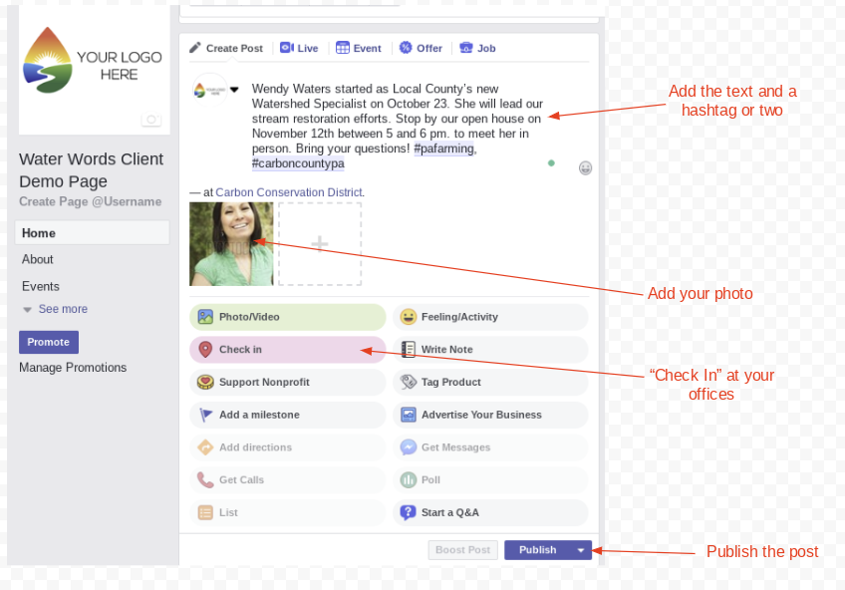

Text Template
Wendy Waters started as Local County’s new Watershed Specialist on October 23. She will lead our stream restoration efforts. Stop by our open house on November 12th between 5 and 6 pm to meet her in person. Bring your questions! #pafarming, #carboncountypa

