Sample Facebook Post

Start Your Post By Clicking the Photo Icon First

Create Your Album

Add Photos, Captions, and Tags
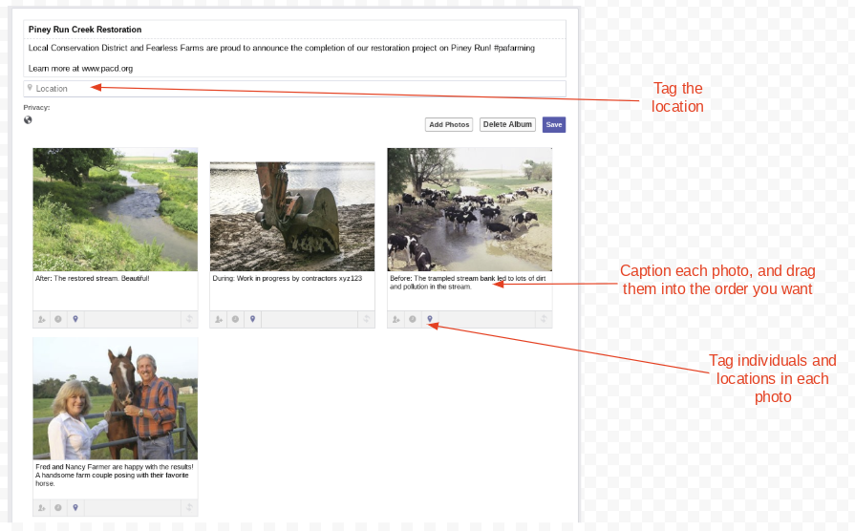

Album Description
Local Conservation District and Fearless Farms are proud to announce the completion of our restoration project on Piney Run! #pafarming, #carboncountypa

Link to learn more: YOUR URL

After Photo
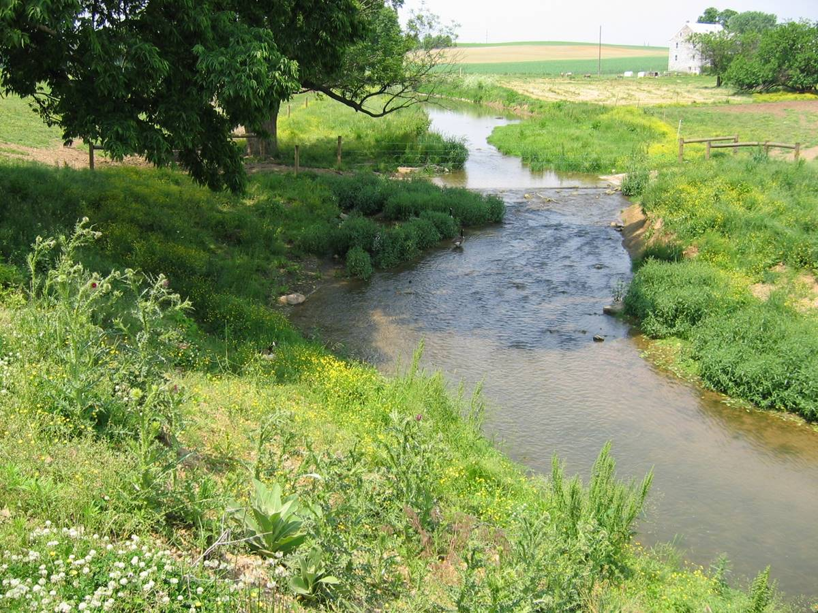

Caption #1: After: The restored stream. Beautiful!

During Photo
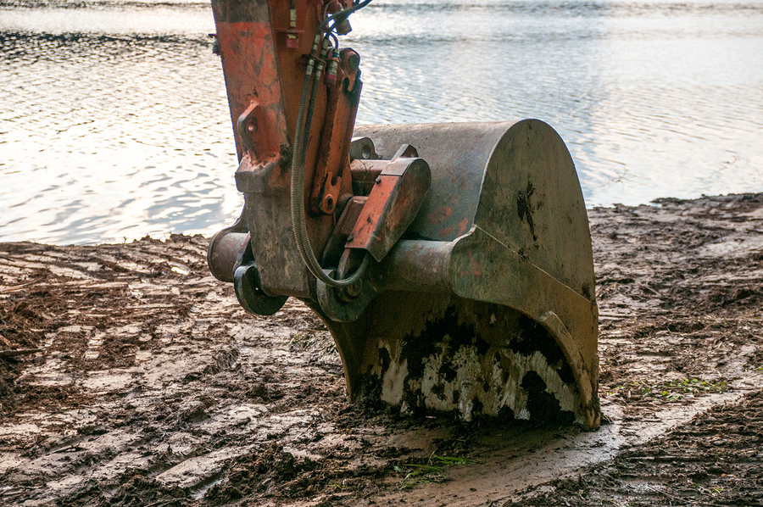
Caption #2: During: Work in progress by contractors xyz123

Before Photo
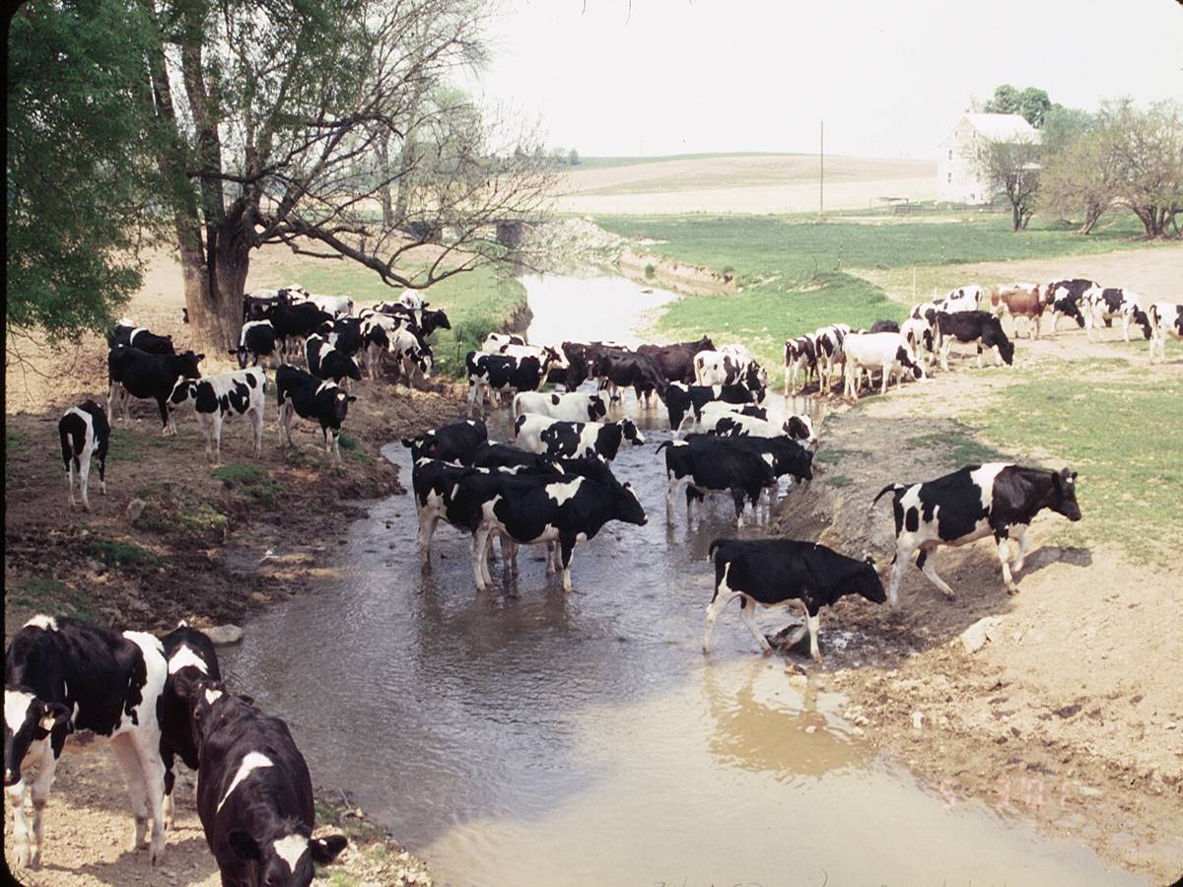

Caption #3: Before: The trampled stream bank led to lots of dirt and pollution in the stream.

Landowner Photo
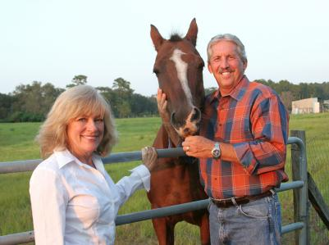

Caption #4: Fred and Nancy Farmer are happy with the results!

