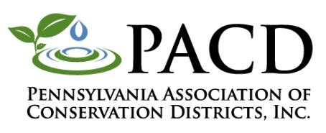
Pennsylvania Association of Conservation Districts, Inc.
CREP Mini-Grant Project Mid-term Report

Conservation District: __________________

Project Contact: _______________________
Completed reports should be emailed to abrown@pacd.org.

Please note: All project related written materials, including brochures, signs, presentations, etc. must be reviewed by PACD’s Program Manager prior to publication/presentation. If you have not yet submitted these items, please do so at this time.

- Briefly describe what you’ve done with your project so far:

- Briefly describe what the next steps are for your project:

- Please describe any changes to your project from how it was outlined in your application: (PACD must pre-approve any budget modifications in excess of 10% of the total grant amount.)

- Describe any roadblocks you’ve encountered to completing a successful project (if any):

