CPEP Program Social Media Guide for Partners
Dear partner, we are currently running a campaign to raise awareness about the CPEP program to enroll more farmers and landowners, and we ask that you share the message with your network to amplify the campaign. We have compiled a guide with some suggested posts to share on your social media channels. You can also use the recommended posts as a guide and create your variations.
It is easy to participate. Copy one of the posts below, download the asset (photo, video, or infographic), go to your Facebook or Instagram page, and add the post. See example below:
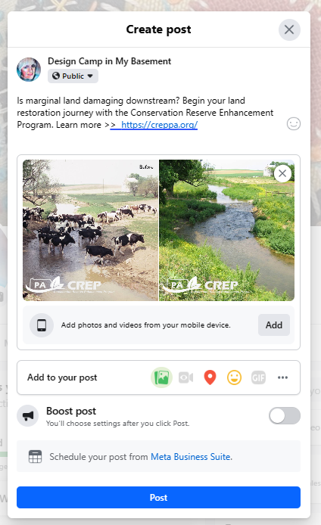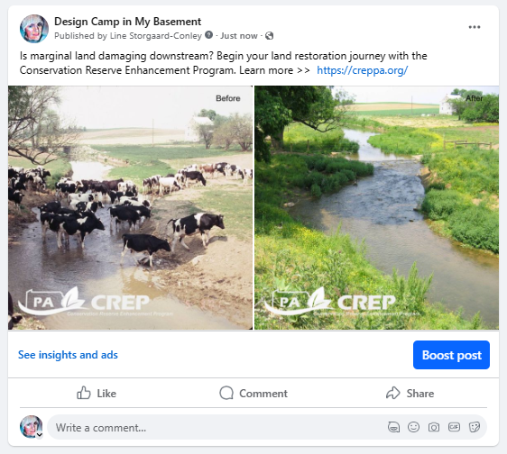
Suggested Posts
Post One
Is marginal land damaging downstream? Begin your land restoration journey with the Conservation Reserve Enhancement Program. Learn more >> https://creppa.org/
- You can find photos here - https://creppa.org/news-photos/ or use one of your photos.
Post Two
Is eroded land dragging your profits? When you restore your farmland with the Conservation Reserve Enhancement Program (CREP), you can receive payments and reimbursements funded by the government. Learn more >> https://creppa.org/
- You can find photos here - https://creppa.org/news-photos/ or use one of your photos.
Post Three
Conservation gives back for generations. Join over 4,000 farms in restoring your land with payments from the Conservation Reserve Enhancement Program (CREP). With CREP, conservation pays. Learn more >> https://creppa.org/about-crep/
- Use our CREP infographic as your social post graphic (link to infographic)
Post Four
Flood-prone land shouldn’t erode your profits. With over $13 million in payments to farmers, the Conservation Reserve Enhancement Program (CREP) can help restore your land and keep profits from going downstream. Learn more >> https://creppa.org/about-crep/
- Use our CREP infographic as your social post graphic. Infographic - CREP PA (Scroll to the bottom)
Post Five
One action benefits a whole environment. Restoring land with the Conservation Reserve Enhancement Program (CREP) benefits your farm, livestock, and community. Watch how these farmers began. Find out how to enroll - https://creppa.org/enroll-re-enroll/
- Use our short video for the post. 30 second video (YouTube)
Post-six
Conservation pays with CREP. Decrease expenses from your least productive land while helping your environment thrive when you enroll in the Conservation Reserve Enhancement Program. Find out how to enroll - https://creppa.org/enroll-re-enroll/
- Use our short video for your social media post. 30-second video (YouTube)

Additional Social Media Tips
Content
Consider excerpts from our success stories for additional social media posts. Also, feel free to tag us on Facebook when you post - https://www.facebook.com/creppa.org.
Hashtags
Suggested hashtags for Instagram: #ConservationPays, #CREPPA, #CREP, #FarmGrants #ConvervationGrants #ProtectYourLand #Conservation
Graphics
Posts that include a graphic or video will likely get more attention and engagement. Use our press and before/after photos to increase impact. Use branded or non-branded images. You can also use pictures from your local projects. You can find the logos on the photo page if you want to add the CREP logo to your photos. Only use images you have permission to use.
Timing & Frequency
Posting regularly will help to increase engagement and help us spread the word about the program to a broader audience. Even just a few posts each month is helpful.
Resharing CREP posts
If you haven’t already done so, please follow CREP, the Pennsylvania Association of Conservation Districts (PACD), and the U.S. Farm Service Agency (FSA) on the social media channels below. When CREP, PACD, or FSA publishes a post about CREP, please like, comment, and/or reshare it. This will enable even more prospective CREP enrollees to see our posts.
- CREP on Facebook
- PACD on Instagram: @paconservation
- PACD on Threads: @paconservation
- PACD on LinkedIn

