Stream Restoration Work to be on Display during Project Tour
Tour to highlight three projects that reduce erosion, flooding, and water pollution

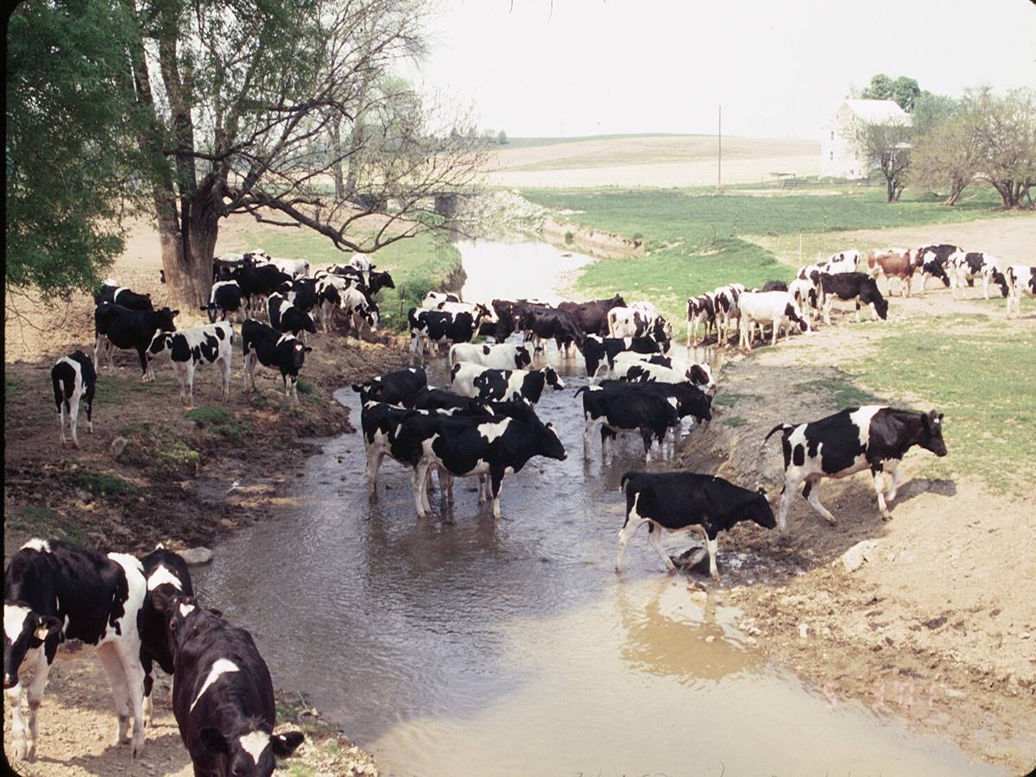 | 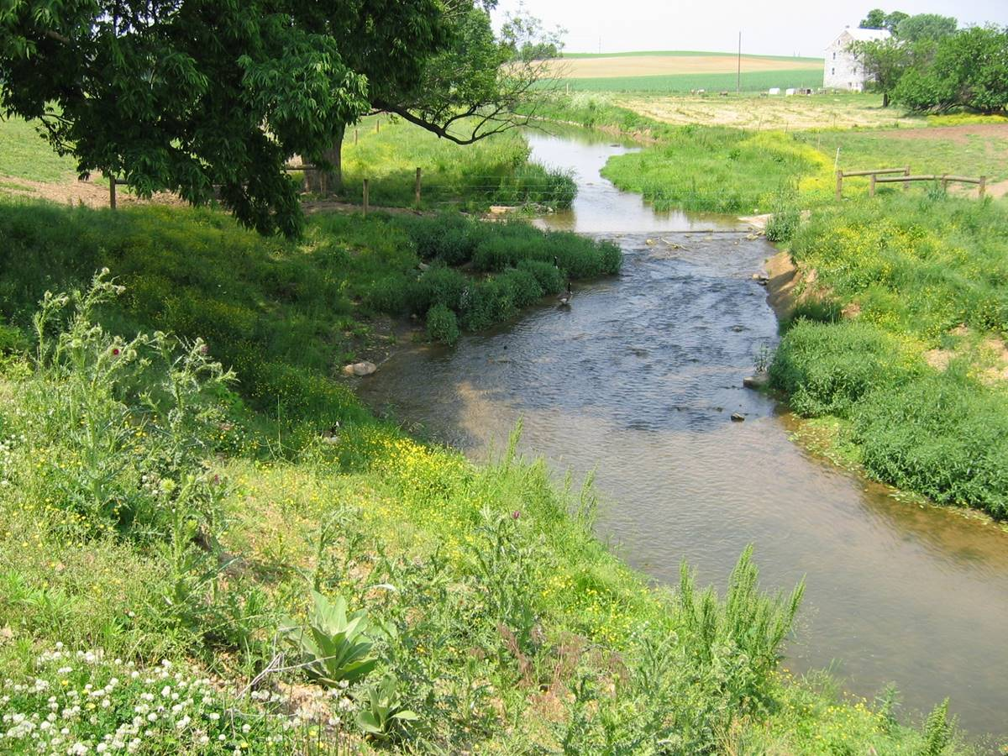

Before After

Photo Caption: Join us to learn how we transformed this stream!

On November 10, 2018, Local Conservation District will hold a tour of three stream restoration projects in Local County. The projects, all completed in the past two years, restored just over 1,000 yards of stream along Piney Creek. The tour will highlight project successes and best practices to reduce erosion, flooding, and water pollution. Local county officials and farmers are encouraged to attend. The general public is invited to participate as well.

“It’s our hope that this tour will lead to similar projects in the future with other farmers in our county,” said Councilman Steve Slicktalker.

One stop on the tour will be at Fearless Farms. The owner, Fred Farmer, spent a number of years watching his pasture slide into Piney Creek. Fred wanted to do something about it before his children took over the farm. He just didn’t know where to start. That’s why he jumped at the chance to partner with Local Conservation District to restore the stream. Volunteers stabilized 300 yards of stream using natural methods and planted hundreds of trees. They also installed 300 yards of livestock fencing.

“I grew up here and spent many days as a young boy playing in Piney Creek,” says Farmer. “I feel good knowing that I am protecting my land and keeping the water clean for my neighbors downstream.”

Other stops on the tour include Daydream Dairy and Outstanding Orchards. Tour participants will get a chance to talk with the farm owners and even get a lesson in water sampling. Nonprofit partner, Piney Run Watershed Association, will be on hand during the tour to answer questions.

“Restoring degraded streams takes teamwork,” says Norma Nonprofit. “I am proud that our group was able to pitch in with tree planting along the streams. Our volunteers enjoyed helping out.”

Other project partners included Pennsylvania Department of Environmental Protection, Penn State, and Jones Construction. Local Conservation District served as the lead for all three projects.

“This tour will show how farmers and our conservation community are working together to make a difference,” said Carla Conservationist with the Local Conservation District, 321 Courthouse Road, Town, PA. “Each of these projects was a labor of love for partners and volunteers alike.”

The tour will begin at 10am outside the Local Conservation District office. Participants are asked to arrive 15 minutes early.

