Piney Run Restoration Benefits Local Farm, Downstream Neighbors
Successful project reduces erosion, flooding, and water pollution

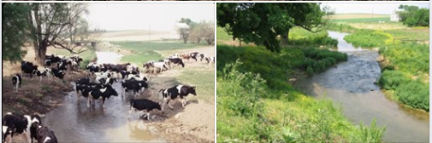
Photo Caption: Before and after photos of stream restoration project.

Local Conservation District and Fearless Farms restored of 300 yards of stream along Piney Creek in October. The project solves erosion headaches and reduces flood and pollution problems downstream. The partners stabilized the bank using natural methods and planted hundreds of trees. They also installed 300 yards of livestock fencing.

“I’ve been watching my pasture slide into the stream for years, but I never knew what to do about it,” said Fred Farmer, owner of Fearless Farms. “It’s great that my kids won’t have to deal with this when they take over the farm.”

Restoring these streams helps the landowner. It also benefits the community.

“We cherish our rural lifestyle here in Local County,” said Councilman Steve Slicktalker. “This shows how farmers and our conservation community can work together to make a difference.”

To complete this project, the partners overcame several challenges. Fearless Farms is a working farm. The partners had to work around planting, harvesting, and weather.

“We can already measure how the water downstream of the site is cleaner than it was,” said Carla Conservationist with the Local Conservation District. “As the trees mature, the stream will improve even more.”

Repairing degraded streams take skill and money. It also takes teamwork. Fearless Farms approved the project and provided matching funds. The Local Conservation District managed the project.

There were many other partners. The Pennsylvania Department of Environmental Protection provided a Growing Greener grant to cover a portion of the cost. Penn State organized a public workshop. Jones Construction stabilized the stream bank. Piney Run Watershed Association recruited the volunteers for the stream planting.

“Our volunteers really enjoyed themselves,” said Norma Nonprofit. “We are looking forward to coming back in a few years to see the growing trees.”

###

