2025-2027 Lawn Conversion and Riparian Buffer Mini-Grant Program for Conservation Districts
EDUCATIONAL SIGNS

Signs: Projects installed on public land require a financial assistance acknowledgement sign. Projects installed on private property do not require a sign. However, a sign is still encouraged to assist with long term asset stewardship. If a sign is installed, it should include the following funding citation:

“Financial and other support for this project is provided by the Pennsylvania Association of Conservation Districts, Inc. through the Community Conservation Partnerships Program, Environmental Stewardship fund, under the administration of the Pennsylvania Department of Conservation and Natural Resources, Bureau of Recreation and Conservation.”
To provide an idea of what a sign should include, the DCNR standard sign specs are listed below. You can use this as guidance and may add other design, educational information, etc.
Please send all designs to Holly Miller at PACD for approval before development.
Standard Permanent Sign Specifications

Sign Size | 24” x 18”
Font Size | Range from .71” to 1.75”
Font Style | Arial
Orientation | Landscape
Base Material | Aluminum
Thickness | 0.08”
Sides Printed | 1
Corners | Round
Base Color | Green
Text Color | White
Border | White
Location | Highly visible area at site of funded project
Mounting Holes | Shall not obstruct any text or logos
Overlay | EG Vinyl
Language/Logo | Specific to program and funding source

Example of sign included on next page

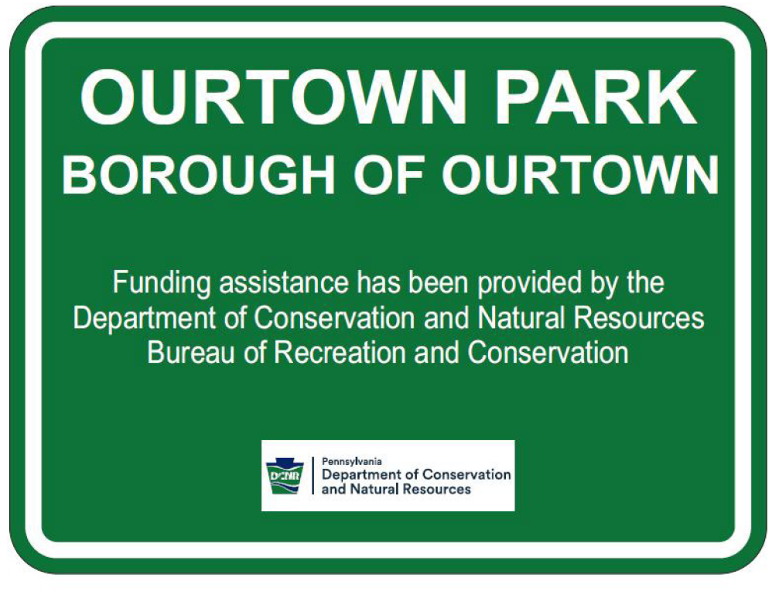

Logos
